AIR UNIVERSITY KAMRA CAMPUS

Project Report
Submitted to: Sir Mustajab Hussain
Submitted by: Affan Farooq (2520067)
Course: Programming for Artificial Intelligence
Date: 5/30/2026

Table of Contents
1. Project Title 4
Introduction 4
Objectives 4
2. Basic Idea of the Project 4
3. Flowcharts 5
Main Flowchart 5
User Registration Flowchart 6
Login Flowchart 7
Transaction Management Flowchart 8
Savings Prediction Flowchart 9
Overspending Risk Detection Flowchart 10
Chart Generation Flowchart 11
4. Module-Wise Description 11
Module 1: User Authentication Module 11
Module 2: File Handling Module 11
Module 3: Transaction Management Module 12
Module 4: Data Preparation Module 12
Module 5: Financial Analysis Module 12
Module 6: Machine Learning Module 12
Module 7: Visualization Module 12
Module 8: Dashboard Module 13
5. Libraries Used 13
6. Dataset Description 13
Dataset File 13
Dataset Attributes 13
7. Assumptions 14
8. Conclusion 14

Project Title
AI-Powered Personal Finance Tracker and Expense Analysis System

Introduction
Managing personal finances is important in everyday life. Many individuals find it difficult to keep track of their income, expenses, savings, and spending habits. Traditional methods such as notebooks or spreadsheets are often time consuming, difficult to manage and do not provide intelligent insights.
This project presents a web based Personal Finance Tracker developed using Python and Flask. The system allows users to register, log in securely, record financial transactions, set budget targets, visualize spending patterns, and receive financial predictions using Machine Learning techniques. The application generates analytical reports and graphical visualizations to help users make better financial decisions.

Objectives
The primary objectives of this project is to create a secure, user friendly finance management system that effectively records and manages financial transactions. It aims to categorize income and expenses, providing users with a clear overview of their financial situation. Additionally, the system will feature graphical visualizations of financial data to enhance user understanding. By machine learning, the project will predict future savings and identify potential overspending risks through logistic regression analysis. Ultimately, the goal is to assist users in achieving their budgeting and savings objectives while offering personalized financial advice based on their transaction history.

Basic Idea of the Project
The project is based on the concept of personal financial management combined with data analytics and machine learning.
The user first creates an account and logs into the system. After authentication, the user can add income and expense records. These records are stored in CSV files and processed using Pandas DataFrames.
The system then performs:
- Spending analysis
- Budget comparison
- Savings calculation
- Risk prediction
- Financial recommendations
Different charts are generated using Matplotlib and Seaborn, allowing users to understand their financial behavior visually. Machine learning algorithms analyze past transaction data and predict future savings as well as overspending risks.

Flowcharts

Main Flowchart
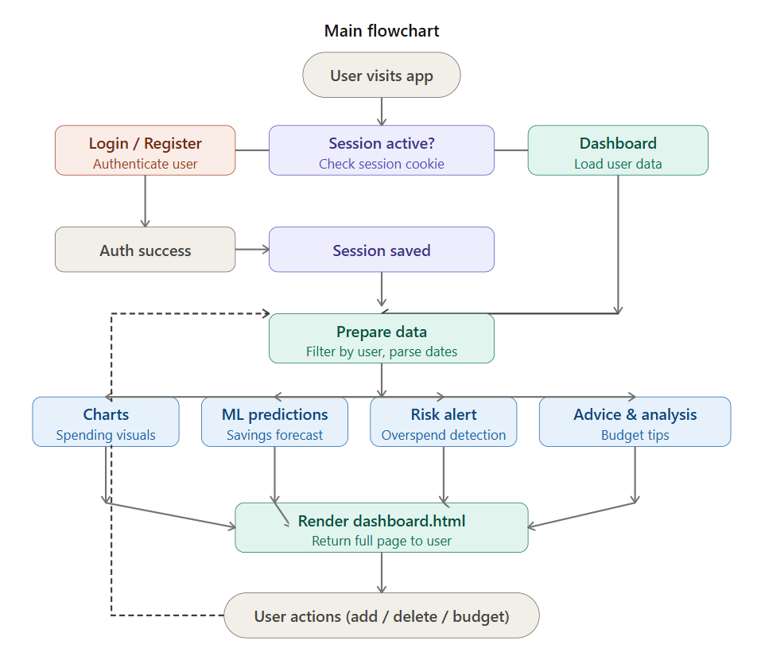

User Registration Flowchart
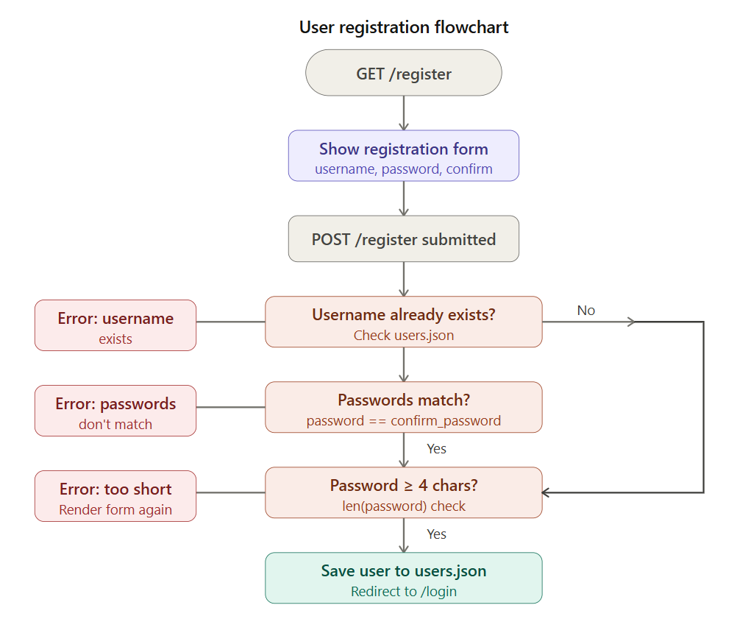

Login Flowchart
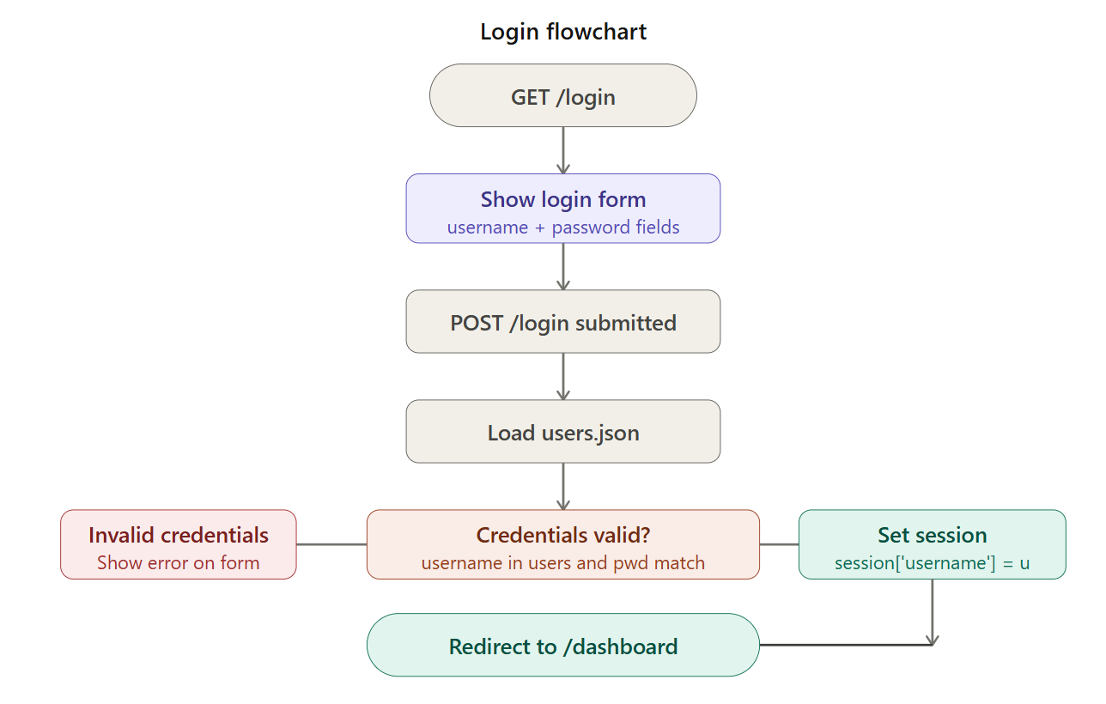

Transaction Management Flowchart
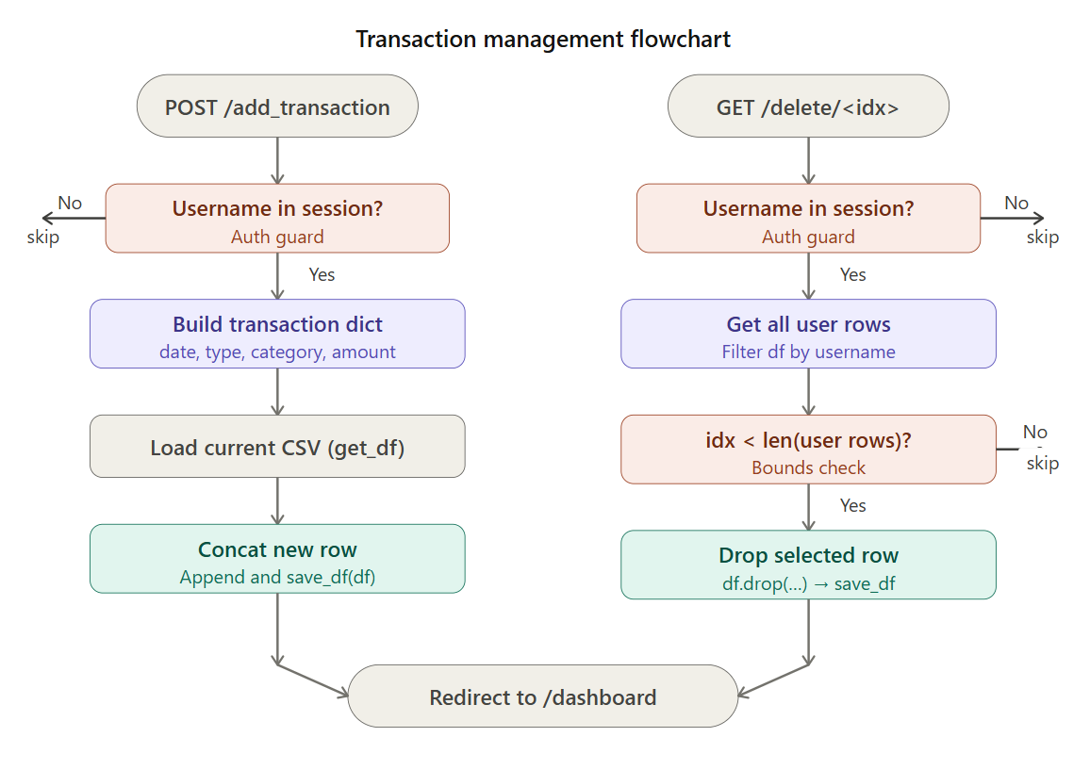

Savings Prediction Flowchart
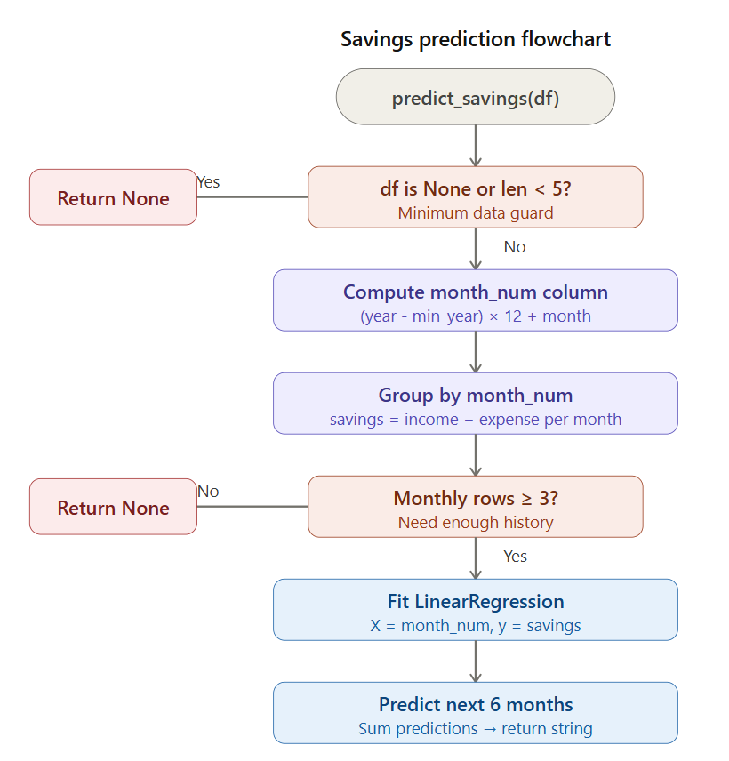

Overspending Risk Detection Flowchart
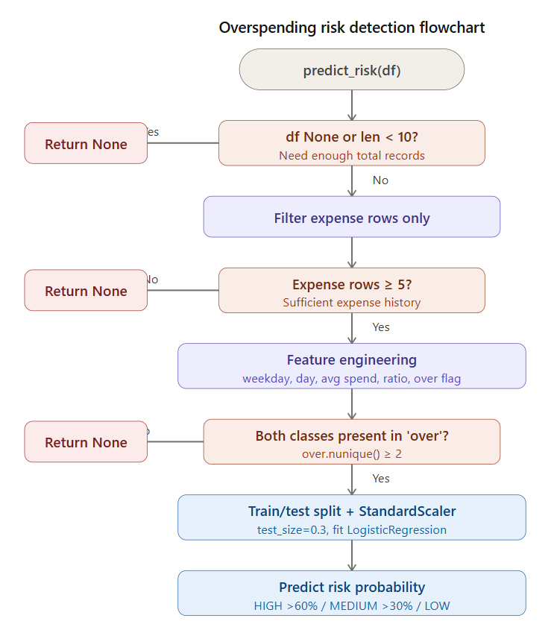

Chart Generation Flowchart
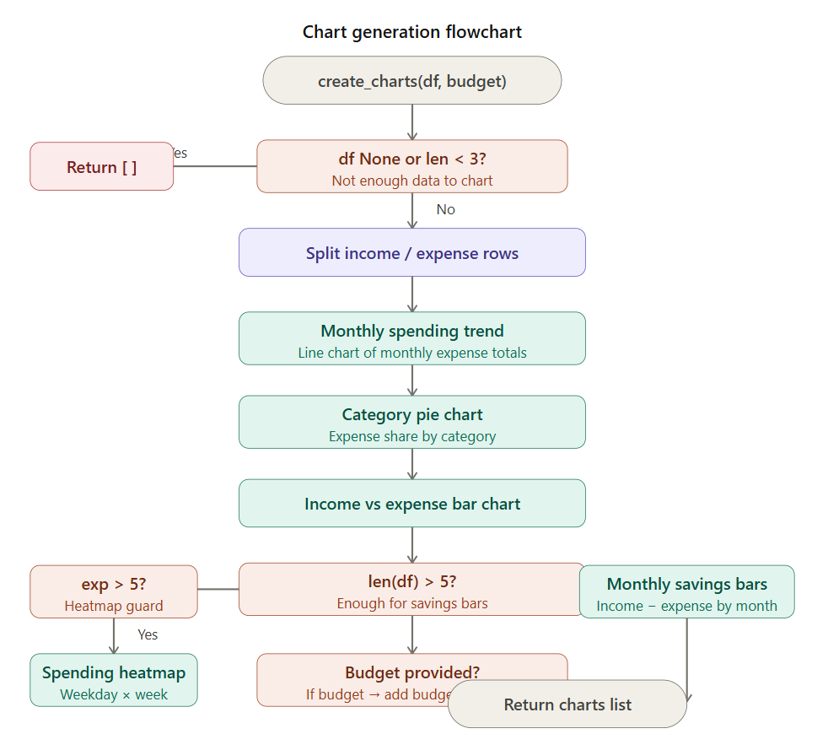

Module-Wise Description

Module 1: User Authentication Module
The register() function validates new data, checks for existing usernames and password matches. login() verifies data against stored records . logout() securely terminates the session by removing the username key and redirects to the login page.

Module 2: File Handling Module
load_users() reads and returns user data from users.json as a dictionary, defaulting to empty if the file doesn't exist. save_users() persists the updated user dictionary back to JSON. get_df() reads transaction records from user_finance_data.csv into a pandas DataFrame, returning empty if absent. save_df() writes the DataFrame back to CSV for persistent storage.

Module 3: Transaction Management Module
get_user_data() filters the full transaction DataFrame by the current username and returns matching records as a list of dictionaries. save_transaction() appends a new transaction row containing username, date, type, category, and amount to the existing CSV via pd.concat(). delete_transaction() isolates the user's records, locates the transaction by its positional index, drops it from the DataFrame by row name, and re saves the updated CSV.

Module 4: Data Preparation Module
prepare_data() takes a user's transactions and makes them ready for analysis. It checks if there are at least 3 records, turns text dates into proper date format, and makes sure amounts are numbers. split_data() then divides this data into two groups: income transactions and expense transactions, so they can be looked at separately.

Module 5: Financial Analysis Module
spending_analysis() looks at a user's expenses, finds which category they spend the most on, calculates their average monthly spending, and checks if their latest month went up or down compared to the previous month. get_advice() checks how much of their income they are saving, tells them if it's good or bad, points out their biggest spending category to cut down on, and suggests how much they should save each day.

Module 6: Machine Learning Module
predict_savings() uses Linear Regression to forecast how much money a user will save in the next 6 months by looking at their past monthly savings trends. predict_risk() uses Logistic Regression to check if a user is likely to overspend. It looks at how much they spend, what day it is, and how their spending compares to their usual habits, then gives a risk level of HIGH, MEDIUM, or LOW.

Module 7: Visualization Module
create_charts() makes several charts from a user's data a line chart showing monthly spending, a pie chart showing where money goes by category, a bar chart comparing income and expenses, a bar chart showing monthly savings, a heatmap showing spending by day of week, and a bar chart comparing spending to budget. create_3d_plot() makes a 3D bar chart showing income, expenses, and savings side by side for each month. fig64() saves any chart as a PNG image and converts it to a base64 string so it can be shown directly on a webpage without saving separate image files.

Module 8: Dashboard Module
dashboard() checks if the user is logged in, loads their cleaned transaction data, gets their budget target, and calls all the other functions to create charts, predictions, and advice. It then puts everything together and sends it to the webpage so the user can see their transactions, charts, savings forecast, risk alert, spending patterns, and budget status all in one place.

Libraries Used
Library | Purpose
Flask | Web Development
Pandas | Data Manipulation
NumPy | Numerical Computation
Matplotlib | Data Visualization
Seaborn | Statistical Graphs
Scikit-Learn | Machine Learning
JSON | User Data Storage
Base64 | Image Encoding
Datetime | Date Handling
OS | File Operations

Dataset Description
The project uses a user-generated dataset stored in CSV format.

Dataset File
user_finance_data.csv

Dataset Attributes
Attribute | Description
Username | Name of the logged-in user
Date | Transaction date
Type | Income or Expense
Category | Transaction category
Amount | Monetary value of transaction

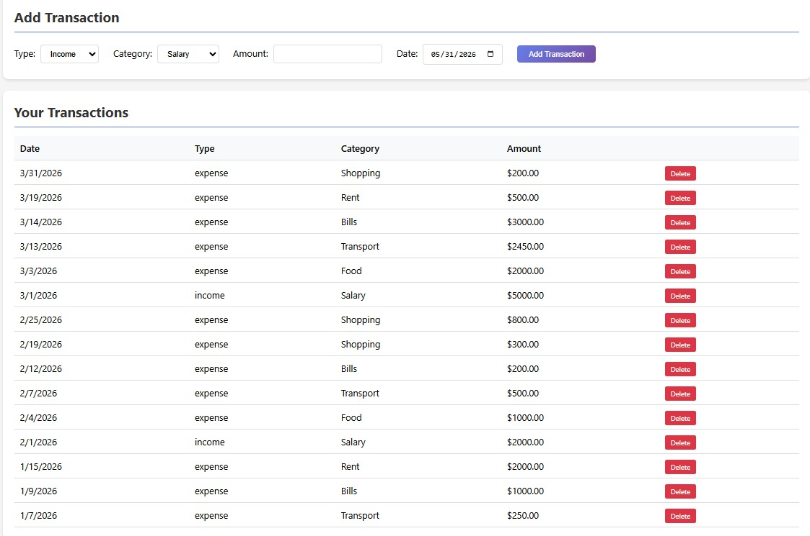
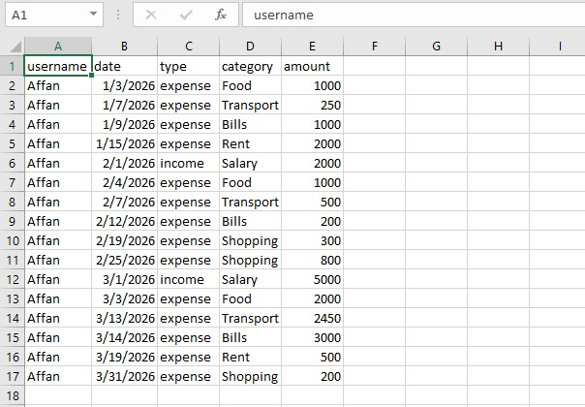

Assumptions
The following assumptions were made during development:
- Users enter valid transaction dates.
- Transaction amounts are positive numerical values.
- Each transaction belongs to either income or expense category.
- CSV files are accessible and writable.
- Sufficient historical data exists for machine learning predictions.
- Users maintain unique usernames.
- Budget values are entered correctly.
- The application runs in a local environment using Flask.

Conclusion
The AI-Powered Personal Finance Tracker helps users manage money by recording transactions, tracking expenses, and showing charts. Machine learning predicts future savings and warns about overspending risks. The project shows how Python, Flask, and data science can solve real money problems.

